
Interference

Objective of the module is to investigate the phenomenon of interference by examining the passage of various types of waves through a double slit structure. This approach provides a deeper understanding of the phenomena of interference as well as diffraction and their interrelationship. Students will learn to calculate interference patterns using both analytical and numerical methods. Furthermore, we will explore the practical applications of interference, with a focus on using a gravimeter to determine the magnitude of the gravitational constant.

Activity with the interface
https://qtechedu.centralesupelec.fr/EN/ex7.html

In this module, we study interference through a double-slit setup for both light and matter particles. We examine how the interference pattern emerges from the superposition of waves passing through the two slits, drawing analogies between classical wave optics—where light behaves as a wave—and the quantum description of matter particles, which exhibit similar wave-like behavior.

1. To analyze the interference of light in a double-slit setup, use the "Visualizer" provided in this section “Interference of light: Double-slit Experiment”. You can control the wavelength of the incident light using the “Wavelength” slider, the slit width using the “Aperture” slider, and the distance between the slits using the corresponding slider. The screen width is 1.25 meters, and the distance between the slits and the screen is 1 meter.
- Give a general definition of interference and describe the conditions required to observe a stable interference patter.
- Explain the conditions under which constructive and destructive interference occur in a double-slit experiment.
- Using the dynamic figure in the interface with the sliders, change the following parameters to observe the interference pattern on the screen (assume the distance between the slits and the screen is 1 m, and the screen width is 1.25 m):
- Vary the distance between the two slits (keep the wavelength constant).
- Vary the wavelength of the light (keep the slit distance constant).
Explain your observations.
- Quantify how the spacing between adjacent bright fringes (constructive interference) depends on slit separation and wavelength.
- Determine the position of the first interference minimum and first maximum for:
- Wavelength λ=500 nm,
- Slit distance d=2.0 µm.
Distance to the screen D=1 m. Calculate their positions on the screen and check whether they appear within a screen width of 1.25 m.
- Determine the maximum number of maxima and minima that can be observed under the given conditions: λ = 400 nm, a = 0.5 µm, a distance to the screen is 1 meter and a width of screen 1.25 meters.
- Discuss how the diffraction envelope (due to the finite slit width) limits the visibility of the interference fringes. Explain the combined effect of diffraction and interference in the observed pattern.

2. In the second section, “Modeling Wave Packet Propagation Through a 2D Slit Structure,” the interference of particles through a double-slit setup is analyzed. To modify the potential profile and wave packet parameters, use the corresponding input fields in the interface. Click the “Update Profile” button to apply the changes. To restore the default configuration, use the “Reset to Default” button. You can also change the calculation parameters, such as the number of points for time discretization, the time step, or the position of the screen.
Once all parameters are defined, run the simulation using the “Run Simulation” button to observe how the wave packet interacts with the slit structure. Note: Atomic units are used in this module *.
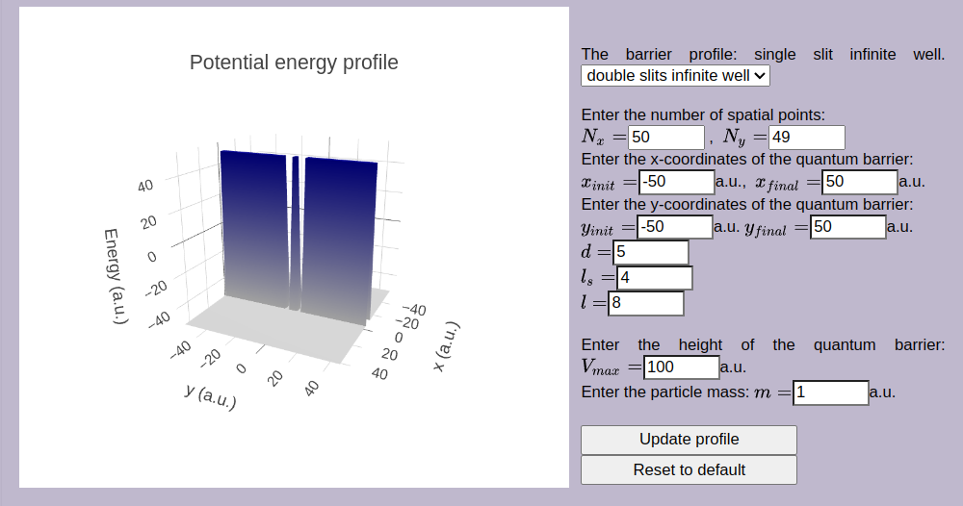
Use the interface to define the parameters used to determine the barrier:
N_{x}, N_{y}:  x_{init}, x_{final}:  y_{init}, y_{final}:  m: | D:  l_{s}:  l:  V_{max}:
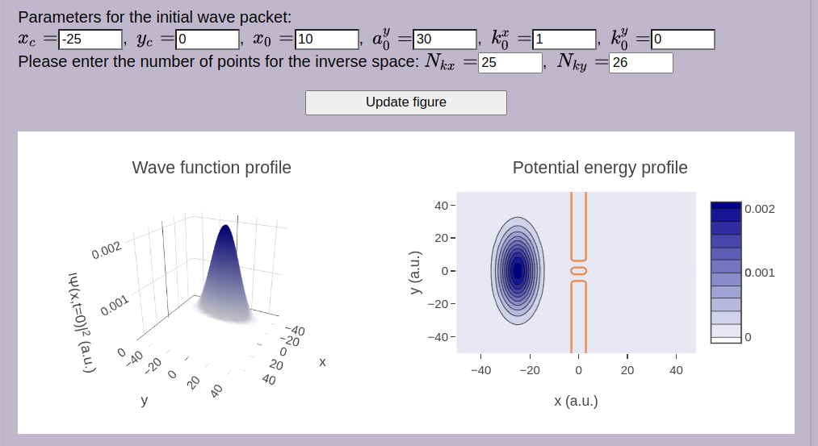
Give definitions of the parameters for the initial wave packet:
x_{c}:  y_{c}:  a₀^{x}: | a₀^{y}:  k₀^{x}:  k₀^{y}:

- Analyze the figures by identifying the physical quantities represented. Describe the quantity plotted on each axis, and interpret the shape and key features of each graph.
- What is a wave packet, and why is it used in quantum mechanical calculations.
- In simulations of particle transmission through a two-dimensional (2D) potential barrier, the Chebyshev expansion method is often used. What are the typical conditions or limits under which the Chebyshev coefficients are well-defined? Additionally, mention and briefly describe other special functions commonly used in quantum mechanical calculations.
- Using the interface, investigate the influence of barrier geometry (such as the width and height of the barrier) on:
- the dispersion of the wave packet;
- its transmission through the barrier;
- the resulting interference pattern.
Note: Atomic units are used in this module *.
- Describe the effect of increasing electron energy on the diffraction (or interference) pattern observed in electron diffraction experiments.
In your explanation, consider how changes in electron energy affect:
- The de Broglie wavelength
- The spacing between interference fringes
- The overall visibility and resolution of the pattern
- Compare the diffraction and interference patterns produced by single slits and double slits for matter particles. Draw analogies with the corresponding patterns observed in light interference and diffraction.

* Atomic units https://en.wikipedia.org/wiki/Hartree_atomic_units are used:

the unit of charge is e = 1 (1.602176634×10⁻¹⁹C);
the unit of mass m_{e} = 1 is defined as the mass of the electron (9.1093837139(28)×10⁻³¹ kg);
the unit of action = 1 - reduced Planck constant (1.054571817...×10⁻³⁴ J⋅s);
the unit of length a₀ = 1 - Bohr radius (= 0.529×10⁻¹⁰m);
the unit of energy E_{H} = 1 - Hartree energy (= 4.359×10⁻¹⁸ J = 27.211 eV).

